Distributed Software Engineering - Software as a Service (SaaS) – inspired in part by userguiding.com/blog/saas-sales-process/
- Future possibility of developing a web based version of our software
- Instead of building this new version for an organization to use, we can instead own and manage the product as our own entity and play the role of a software provider
- Offer the route optimization and average time-to-delivery algorithm under a subscription based or pay per use model (with a free trial option to begin).
- Calculate fair pricing by comparing to other similar products and accounting for the cost of development that it would take for an organization to have their own version of the software developed.
- Then we would enter into our SaaS Customer Interaction Plan as defined by the diagram below:
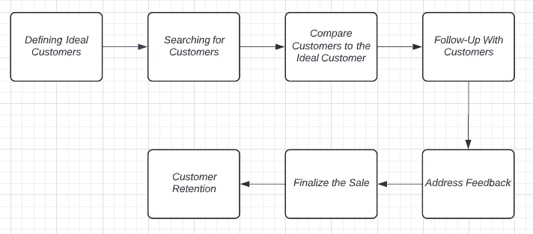

- We would have to define an ideal customer: in general this would be a customer who frequently uses and relies on our software and is likely to continue using our service.
- Searching for customers would include advertising to potential customers and conducting research to discover potential ideal customers to make direct contact via emails, over the phone meetings, or even in person presentations.
- After finding customers, we would want to assess the value they bring to our business compared to our predefined ideal customer. This is to ensure that every customer is a net positive for the business and the product's success.
- For customers who signed up for a free trial, this could mean having conversations to get them to enroll in a paid subscription for the service. For customers who already have subscriptions, this could mean sending them reminders to renew their subscription or sign-up for an auto-renewal plan.
- Addressing feedback would signify responding to any questions and concerns that the customer presents or might have. This would include reiterating the value that the software brings to them and ensuring that they are fully aware of the capabilities of the software. Feedback may also come in the form of requested features, addressing feedback would also include consideration of feature requests for the future.
- Finalizing the Sale means entering a longer term agreement in the form of a contract with the ideal customers that we have engaged with and discovered.
- Customer Retention is accomplished through the providing of reliable customer service and making new user training and guides to using our services available to the customer on demand,

